**Literature and Disability  
Alice Hall**First published 2016  
by Routledge  
2 Park Square, Milton Park, Abingdon, Oxon OX14 4RN   
and by Routledge  
711 Third Avenue, New York, NY 10017  
*Routledge is an imprint of the Taylor & Francis Group, an informa business*© 2016 Alice Hall  
  
  
*This e-text has been compiled solely for educational use and should be compatible with screen readers and other accessibility software. Page numbers in this document match those in the print edition of Hall’s text.* 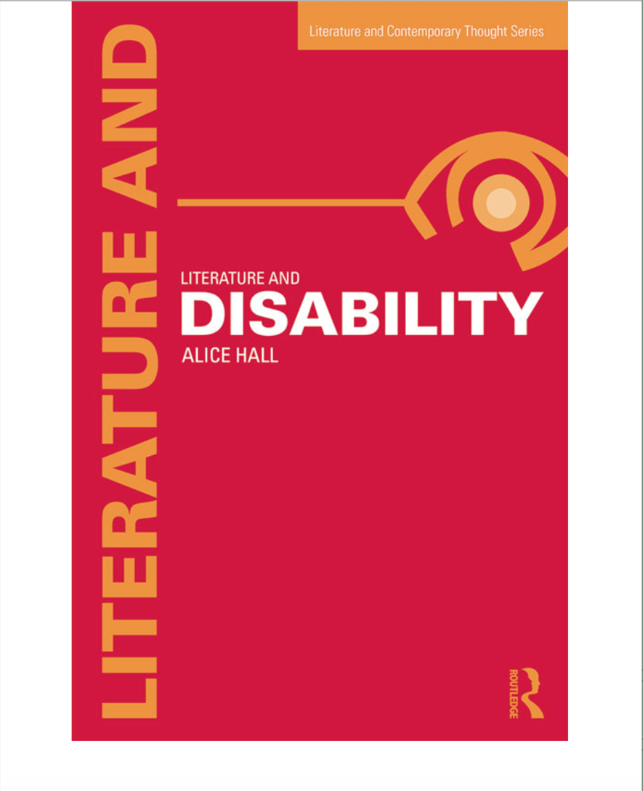

# 

# **3. Literature and Disability**

## The Cultural Model and the Rise of “Literary Disability Studies”

Writing in her 1926 book on cognitive impairment, The Almosts, Helen MacMurphy commented:

Sometimes the poet sees more than the scientist, even when the man is playing his own game. The novelist can give a few points to the sociologist, and the dramatist to the settlement worker.

(1)

In the book, MacMurphy calls for a multidisciplinary model of disability that places social sciences and the arts alongside medical understandings. *The Almosts* fuses activism and literary criticism as it calls for better treatment of so-called “feebleminded” people in institutions in the United States in the 1920s. MacMurphy uses examples from fiction such as Dickens’s Tiny Tim, a character narrated entirely from an external perspective, to argue that state authorities and individuals should pay more attention to the interior lives and emotional well-being of people with disabilities living in state institutions. In doing so, MacMurphy highlights a paradox that modern disability studies scholars have only recently begun to respond to: the gap between the prevalence of representations of disability in literature and culture and the social marginalisation of people with disabilities.

In the 1970s and 1980s, disability studies was dominated by social science perspectives, exemplified by the political and sociological focus of some of its leading organisations and publications such as The Society for Disability Studies, and journals including Disability Studies Quarterly and Disability and Society. It was not until the late 1980s and 1990s that, given a boost by the growth of cultural studies, disability studies was taken up in a sustained way by scholars in the humanities (Davis “Crips

Strike Back: The Rise of Disability Studies” 508–9). Since then, scholars including Rosemarie Garland-Thomson, Lennard Davis, Brenda Brueggemann, David T. Mitchell and Susan L. Snyder have put literature at the heart of their critical examinations of disability and the “normal” body, analysing works by authors with disabilities, cultural works that depict disabled characters, and texts that deal with disability on a level of metaphor. In the UK, David Bolt and Lucy Burke have argued that literary and cultural disability studies is not a marginal “decorative discipline”, but rather a key framework for analysis that contributes significantly to the overall project of disability studies and deserves greater institutional recognition (Goodley 15; Bolt 1). Following Tobin Siebers’s definition of disability studies, literary and cultural texts are seen as providing rich material for analysis, and a humanities training is valued for teaching scholars valuable analytic skills, theoretical frameworks and methodologies:

Disability studies does not treat disease or disability, hoping to cure or avoid them; it studies the social meanings, symbols, and stigmas attached to disability identity and asks how they relate to enforced systems of exclusion and expression.

(Disability Theory 4)

This work, sometimes referred to as the “cultural model” of disability, or more specifically “literary disability studies”, is the focus of this chapter. The chapter provides an overview of shifting approaches to literary disability studies and considers some of the key, ongoing debates that bind scholars together: debates about empathy, the status of disability as a metaphor, and the intersections between cultural disability studies and postcolonialism, feminism, gender and queer theory. The cultural model destabilises the traditional distinction between “disability” and “impairment” made by social model theorists. For these cultural critics, social identities and even the materiality of the body cannot pre-exist or be separated off from systems of language and culture (Stiker 14; Siebers Disability Theory 2).

Many recent scholars have echoed MacMurphy’s sense that although there has been a proliferation of representations of disability across different cultures and periods, literary and cultural critics have often failed to analyse or even acknowledge the presence of disability. How often, for example, has *King Lear* been discussed with no specific mention of disability? Or, to take more recent examples, how can the significance of the impairments represented in Steinbeck’s *Of* Mice and Men (1937) or Beckett’s Endgame (1957) be overlooked? Stuart Murray draws attention

to the persistent representations of disability in modern and contemporary writing (241); David Mitchell, in his Foreword to Stiker’s A History of Disability (1999), takes a wider, cross-period perspective to suggest that the segregation and marginalisation of disabled people in many societies has coexisted with literary and cultural representations that make “difference into a paramount trope of the human condition” (ix).

The first wave of writing in literary and cultural disability studies therefore focused on revealing and recuperating this wealth of works by disabled authors and intellectuals, and on analysing fictional characters and existing works of literary or cultural theory that engage with disability. Davis, for example, takes a biographical approach to the recuperative project as he asks his readers to consider whether they had ever previously thought of John Milton, Sir Joshua Reynolds, Alexander Pope, Harriet Martineau, John Keats, George Gordon Byron, Henri de Toulouse-Lautrec, James Joyce or Virginia Woolf as disabled. He goes on to retrospectively “claim” some classic works of cultural theory for disability studies, including work by Sander Gilman on disease, David Rothman on asylums, and Leslie Fielder on freaks (Davis “Introduction” xvi–xvii).

This project of identifying disability, rooted in the original activist foundations of disability studies, brings with it a commitment to challenging stereotypes of disability in cultural representations. The recuperative agenda can therefore be seen as having an impulse towards historical revisionism. Scholars have critiqued the ways in which fictional characters with disabilities have so often been invoked as straightforward symbols of evil, exoticism, weakness or ugliness (Garland-Thomson Extraordinary Bodies: Figuring Physical Disability in American Culture and Literature 9). They have identified the ways in which disability is used as a defining trait, as either a “moral index” for the characters themselves, or as a kind of barometer to account for how other characters choose to treat those perceived to be of lesser standing (Bérubé 569–70). This is important cultural criticism that complements and extends social campaigns to change attitudes towards disability. These critics explore recurring stereotypes perpetuated by literary texts and argue that archetypal disability narratives are often misrepresentations which fail to do justice to the complexities of disability as an identity, a way of being in the world, or an embodied, lived experience. Stereotypical narrative scripts have the potential to reinforce ableist conceptions of disability as an absence; disabled characters are, these scholars argue, often used merely as a tool to reveal something about the non-disabled protagonists (Murray 249).

Lennard Davis suggests that this idea of disability functioning merely as a means of illuminating or reinforcing the norm works not only on the level of character, but also at the level of genre and form. He suggests that

the novel is an inherently normative, conservative form which has the potential to directly inform an individual’s world view:

I am not saying that novels embody the prejudices of society towards people with disabilities. That is clearly a truism. Rather, I am asserting that the very structures on which the novel rests tend to be normative, ideologically emphasizing the universal quality of the central character whose normativity encourages us to identify with him or her. Furthermore, the novel’s goal is to reproduce, on some level, the semiologically normative signs surrounding the reader, that paradoxically help the reader to read those signs in the world as well as the text. The middleness of life, the middleness of the material world, the middleness of the normal body, the middleness of a sexually gendered, ethnically middle world is created in symbolic form and then reproduced symbolically.

(“Constructing Normalcy” 11)

Davis views the novel as one of a number of “public venues” in which the “abnormal” is represented in order to bolster hegemonic ideas of the normal in terms of race, class, gender and dis/ability – a theory he refers to as “enforcing normalcy” (“Constructing Normalcy” 12). In particular, Davis makes a compelling case for the “normalcy” of the novel form as a means of reinforcing ideas of the norm in relation to bodies and social identities.

However, this view fails to acknowledge the potentially diverse range of forms of novels themselves and the agency of critics in bringing different critical models of reading to a particular text. While other literary disability studies critics, like Davis, have looked to novels for examples of oppression and misrepresentation, they have also found alternative figures of empowerment that challenge dominant discourses and prejudice. Garland-Thomson’s seminal work, Extraordinary Bodies: Figuring Physical Disability in American Literature and Culture (1997), for example, celebrates a genre of “black women’s liberatory novels” about disability that includes works by Toni Morrison and Audre Lorde (6). Garland-Thomson focuses on figures of resistance such as Eva Peace, a poor African American female amputee who is a mesmerising presence at the centre of Morrison’s novel, Sula (1973): powerful, sexually attractive and a great storyteller in her own right (Extraordinary Bodies: Figuring Physical Disability in American Culture and Literature 124).

Reading and analysing cultural texts from a disability studies standpoint can itself be seen as providing a way of disrupting assumptions and critiquing ideology; these critical readings can be productive and

sometimes progressive, even if the fictional texts analysed contain very restricted understandings of disability. Recently, therefore, scholars have sought to qualify and complicate approaches in which literature is used as a tool to either “search for a more ‘positive’ story of disability”, or to “spot” examples of prejudice and injustice (David T. Mitchell and Sharon L. Snyder “Narrative Prosthesis and the Materiality of Metaphor” 212; Murray 249). This is not, they suggest, to deny or ignore the valuable project of documenting and exposing examples of social oppression and the role that literature plays in both reflecting and perpetuating damaging myth-making processes about disability. Rather, it is to push the discipline further, challenging approaches that have tended to treat fictional characters as “real people” or have overlooked the potential for literature to act as a site of resistance or creative re-imagining (Bérubé 570). Murray, for example, acknowledges the “continuous and highly problematic” use of disability in fiction in ways that “emphasize values that negate the presence and meaning of disability” but, at the same time, he looks at other literary writing that generates a sense of the “productive presence” of characters with disabilities (241).

Contemporary critics continue to debate how disability studies, as a discipline that is committed to engaging with the lived experiences and social campaigns led by people with disabilities in the present, can best engage with close textual analysis and theoretical framings of literary works from across different settings and periods. Literary critical language and strategies have informed some of the most ambitious cross-disciplinary work in disability studies. In his History of Disability, Stiker places examples from literature alongside historical case studies. The project is, he suggests, best conceived of as a “semiotics of cultures”, which is methodologically rigorous and historically astute precisely because it acknowledges its own status as a constructed narrative of the past, as a “fiction” (Stiker 20; 19). Siebers, whose work sits at the intersection of cultural theory and studies in visual culture, echoes this sense of the importance of thinking about processes of reading in the broadest methodological sense. “Oppression”, he argues, “is driven not by individual, unconscious syndromes but by social ideologies that are embodied, and precisely because ideologies are embodied, their effects are readable, and must be read” (Disability Theory 30). For Siebers, focusing on texts and culture does not distract from concerns of material embodied experience; instead, the material, textual, and cultural are all closely interwoven.

This emphasis on productive processes of critical reading, and the potential for some literary

representations to offer complex, even radical, non-normative characterisations of disability, has endowed the field with a striking critical energy in recent years and has opened up exciting new challenges. Some of these challenges and key concerns in recent literary disability writing are introduced below; they also inform the analysis in the chapters that follow.

## Empathy

Debates about the ethics and aesthetics of empathy and the role that literature can play in processes of identification are central to the recent “ethical” or “affective” turn in literary and cultural studies (Attridge; Nussbaum; Keene). These debates take on a particular significance in the context of literary disability studies where terms such as empathy, pity, fear and abjection are highly politicised and hotly contested. These debates are often conceived of in terms of the relationship between reader and text, or between disabled and non-disabled individuals. Sue Halpern, for example, argues that while sympathy is a possibility, “empathy for the disabled is unavailable for most able-bodied persons” because their attempt to project themselves into another condition is always mediated by their knowledge of their own body’s ability (3). Feminist philosopher Susan Wendell takes a similar but subtly different perspective on this debate. She suggests that it is absolutely possible for people to imagine other states of being: “women can identify with a male protagonist in a story”, for example (Wendell 248). But, she argues, disability constitutes a special case: the barrier is not an inability to imagine disability but rather a deep-rooted desire not to do so because of the fear, pity and even revulsion that is often associated with disability in contemporary cultural life. Both Wendell and Halpern share a strong sense of the failure of identification, and particularly the failure of non-disabled people to make the “imaginative leap” into the skins of those who are physically or cognitively different from themselves. While the uneven dynamic of pity is possible, the reciprocal relationship of empathy remains, they argue, unavailable.

By contrast, some literary disability scholars have argued that literature provides a unique location in which imaginative identification may be possible. Mitchell and Snyder do not underplay the difficulty of the task of imaginative identification, but they suggest that narrative can play a key mediating role:

To represent disability is to engage oneself in an encounter with that which is believed to be off the map of “recognizable” human experiences. Making comprehensible that which appears to be inherently unknowable situates narrative in the powerful position of mediator between two separate worlds.

(Narrative Prosthesis: Disability and the Dependencies   
of Discourse *5*)

This view suggests that narrative acts as a bridge between individuals. In a later article, Snyder and Mitchell elaborate: “by definition, literature makes disability a social, rather than a medical phenomenon” (“Disability Haunting in American Poetics” 6). Literary narrative allows, they suggest, an “intimacy” with disabled characters that is a “rare exception” amid the social marginalisation of people with disabilities (Snyder and Mitchell “Disability Haunting in American Poetics” 6). These arguments connect to debates outside of disability studies about the ethical value of literary writing, and even the wider value of the arts, as ethically significant “other-directed” acts (Attridge). They draw readers, as well as scholars, into a dialogue about their own role in actively constructing a narrative and the characters within it.

## Disability and Metaphor

The debates about empathy and the focus on the problems and possibilities of narrative as a mediator, a means of understanding an apparently “unknowable” or alien position in terms of something else, are closely linked to debates about the ethics of using disability as a metaphor. If metaphor is understood according to its etymology, as a vehicle for “carrying” meaning from one place to another, then it may itself be seen as a mediating device that has the potential to bridge gaps in empathetic understanding or communication. The use of disability metaphors in literature has, however, been viewed with suspicion by many cultural disability studies theorists. Many “first wave” scholars highlight the tendency for disability to be invoked in literature as an easy metaphorical shortcut: a marker of pity, vulnerability or, less frequently, the heroic “supercrip” (Davis Enforcing Normalcy: Disability, Deafness, and the Body 106). They emphasise how distant these metaphors are from the actual lives of disabled people or the embodied experiences of disability. They condemn them for misrepresenting disability and attracting attention away from material concerns. For example, in his seminal essay, “Disability as Metaphor in Literature” (1988), Leonard Kriegel argues that literary representations tend to depict disability as either a source of pity or a threat, and “in the history of Western literature, both before and after Shakespeare, there is little to be added to these two images” (7). Shari Thurber sees the metaphoric use of disability as “a most blatant and pernicious form of stereotyping” (12). The title of Kathleen Tolan’s article for American Theatre: “We Are Not a Metaphor: A Conversation about Representation” (2001) encapsulates this wholesale rejection of metaphor.

The most influential theorisation of this resistance to metaphor is found in David T. Mitchell and Sharon L. Snyder’s *Narrative Prosthesis:*